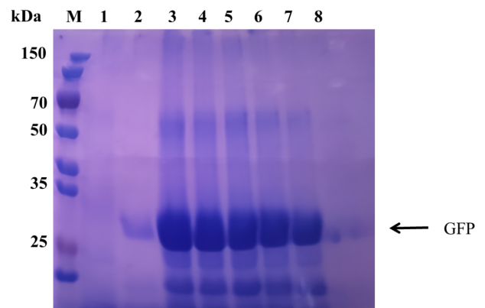

Fig. S3 SDS-PAGE analysis of whole cell extracts. M: standard protein marker. Lane 1, A164T7P (empty vector); Lane 2, P43-GFP; Lane3-8, T7-GFP with 1%, 0.8%, 0.6%, 0.4%, and 0.2% (m/v) D-xylose induced, respectively.

